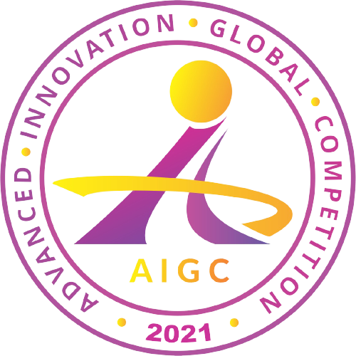

Advanced Innovation Global Competition
APPLICATION FORM

Instructions

Please complete the application form for your work (invention, academic paper, etc). All text must be written in English. Submit the application form at the Advanced Innovation Global Competition page, accessible via the registration link at www.aigc-singapore.com no later than the 15th of November, 2021, unless there have been any updates to the deadline.

Make sure to complete the payment of $350 USD until the deadline.

Applicant Information
Country
Name of Supervisor
Email
Phone
Institution, School, or Organization
Address  (awards and certificates will be mailed to this address) | Street:  City:  Province:  Country:  Zip Code:
Submission Information
Tittle of Work
(invention, academic paper, etc.)
Name of Team Members
Category  (please choose the most relevant category) | - Agriculture  - Architecture  - Arts and Music  - Chemistry  - Computer Science  - Artificial Intelligence  - IoT  - Internet Services  - Education  - Engineering  - Environment  - Health and Medicine  - Public Safety  - Sports and Fitness  - Transportation  - Other (please specify)
Description
(detailed description of the important aspects of this work such as novelty/creativity, technical achievement, commercial/business potential, etc.)
Photo(s)

This document template is owned by AI-JAM Association and may not be used anywhere outside of AI-JAM official competitions, without written consent.

